**Memorandum**

**Date:** February 23, 2023

**To:** Bill & Melinda Gates Foundation – Global Health Sector

**From:** Hong Kong - Shanghai Business Analysts (founded by Issac Chan and Eva Wang)

**Subject:** Save the Children, Save our Future: Deep Learning for Pneumonia Diagnosis

**Executive Summary**

Preventable death by pneumonia is one of the major causes of death in children under age 5 in developing countries. To augment the diagnosis process, our team developed convolutional neural networks (CNN) with validation AUC consistent at 99.7% and higher. We offer two types of models for Sub-Saharan African countries either in the urgent need to suppress pneumonia or in the long-term management of pneumonia. We are now seeking $2 million in funding to conduct field tests in Sub-Saharan Africa and we have connected to Zimbabwe hospitals to be our initial test areas. With a Level 1 Cost-Benefit Analysis, our model would cost Zimbabwe hospitals $741,969 per year, which saves 54% ($879,789) cost than the naive method and would annually save $6,767,608 if applied to Sub-Saharan Africa. We believe our model will greatly contribute to the Gates foundation’s emphasis on children’s health.

**Project Background**

For every 45 seconds, at least one child would die due to preventable pneumonia, most of which occurs in the developing world (“Childhood pneumonia”, n.d.). A chest X-ray is the most common way to diagnose pneumonia. For regions with thin radiologist bandwidth and/or poor diagnostic power, a deep learning model, such as CNN, can augment the efficiency of diagnosis and even automate the process for regions with limited medical resources, such as Zimbabwe.

CNN is one of the most developed deep learning algorithms in image recognition. It uses a shared-weight architecture of the [convolution](https://en.wikipedia.org/wiki/Convolution)al filters that slide along input figures and generate corresponding feature maps which capture the pattern of the image. Built upon neural networks, the model uses backpropagation to learn and adjust the weights for each epoch. There are three different levels of tuning CNN: parameterized, nuanced, and keras tuner. Parameterized focuses on the model parameters (e.g., batch size, learning rate, etc.); the nuanced method allows changes of parameters in each layer; and the keras tuner is a tuning library that searches for the optimal set of parameters for the model. We mainly focused on parameterized and nuanced methods.

**Model Overview**

In the process of building the model, we did not set any seed to ensure that it does not fit particularly on one group of data. Our best model performance has AUC ranging from 99.68% to 99.81%. The tuning process can be split into three main parts: the nuanced model, parameterized model, and data augmentation. The nuanced model and parameterized model are two separate routes that allow us to tune the model differently. Max pooling remains unchanged in both the nuanced model and parameterized model. Max pooling can provide a larger contrast between the color shown on the X-Rays images, which improves learning efficiency. Since we are developing a system for Zimbabwe, we considered that the efficiency and accuracy of the model are both important when we evaluate our model.

We discovered that the parameterized model with data augmentation is an efficient model with higher AUCs. Data augmentation overcomes the downside of limited training data by creating more training data with different angles and dimensions. After tuning with different parameters, the batch size at 16 with 1 layer with 32 filters is the most optimal. Small numbers of filters and layers correspond to the smaller X-Rays sizes. Also, running 8-12 epochs with a 0.0001 learning rate in the parameterized model would generate the best performance in validation data with AUC at 99.5%. This model is extremely efficient with a reasonable level of confidence, taking 4-5 minutes to run. However, the variance of this model is higher than the nuanced model, making this relatively less reliable.

The nuanced model takes longer to run through each epoch and usually requires 30 to 40 minutes to run through 100 to 120 epochs. As our strategy is learning with a small number of filters with a high number of epochs, we discovered that 3 layers would give solid performances with 16, 32, and 64 filters. The dropout rate is set to 0.2 to ensure that the model is not overfitting. Since we would like to have a more accurate model, we decided to take out two max pooling operations to increase the details that we can capture from train data. The AUC can reach 99.7% or above consistently.

In short, depending on the needs and medical conditions in each Sub-Saharan African country, we recommend the parameterized model for countries in urgent need of reducing mortality of pneumonia and the nuanced model for countries in the long-term and sustainable management of pneumonia. Besides AUC, the appropriate level of confidence in our model, another focus is to reduce the False Negative rate. After all, we want to eliminate preventable death among children by reducing any chance of missing possible pneumonia patients. Our model has false negative rates ranging from 0.69% to 2.81%.

**Model Application**

We selected Zimbabwe as our initial field application market. Despite the initial years of struggle with morbidity and mortality of children under 5 years old (Kebede, Mason, & Qazi, 2003), Zimbabwe now focuses on reducing pneumonia in a sustainable method. Thus, we used one of the cost matrices from the nuance model to conduct a cost-benefit analysis (see Figure 1). In 2022, the total population in Zimbabwe was 15.3 million, and 41% of the population is from 0-14 age (“World population”, n.d.). If we assume an equal distribution of age, there should be 2,240,357 children under age 5. Globally, nearly 22% of children suffer from pneumonia (“Pneumonia in children”, 2022; POP1, n.d.), and considering the health condition in Zimbabwe, we would estimate 25% of children would show pneumonia symptoms. However, only two-thirds of children in Zimbabwe seek appropriate care (Fighting, n.d.). Thus, our target population will be 373,393 per year.

Antibiotics, which could prevent 70% of all pneumonia deaths, cost just $0.50 on average, which is very minimal (Fighting, n.d.). Thus, under False Positive cases, medical staff’s efficiency is a more pressing cost for the healthcare system, since medical staff needs to spend time treating healthy patients. Hospitals spend $10,221,072 (inflation-adjusted) on medical staff salaries and hospitals usually have 300 medical staff (Grimes et al., 2017). Assuming all medical staff works 50 hours per week, the average salary per hour per staff would be $13 and we assume that medical staff would spend 1 hour for each patient. For False Negative diagnoses, we suspect the patient already missed the optimal window for treatment, and thus more intense treatments, such as ICU, are required. One bed in ICU would cost $85 per day (Okafor, 2009) and we assume each patient would stay one night on average. Thus, a Level 1 Cost Matrix results in a total cost of $741,969 per year for Zimbabwe (detailed calculation in Table 1).

Now, if we benchmark this to the naive method, which assumes hospitals would over-medicate all potential patients regardless if they are healthy or not, besides the challenge of WHO’s medical supply, this situation will greatly reduce efficiency and result in the total cost at $1,621,758 which is 54% ($879,789) more than our model. Considering that our model aims to be implemented in Sub-Saharan Africa, we can save $6,767,608 in total (Zimbabwe’s population is 13%).

Appendix

**Figure 1.** Confusion matrix from the nuance model.

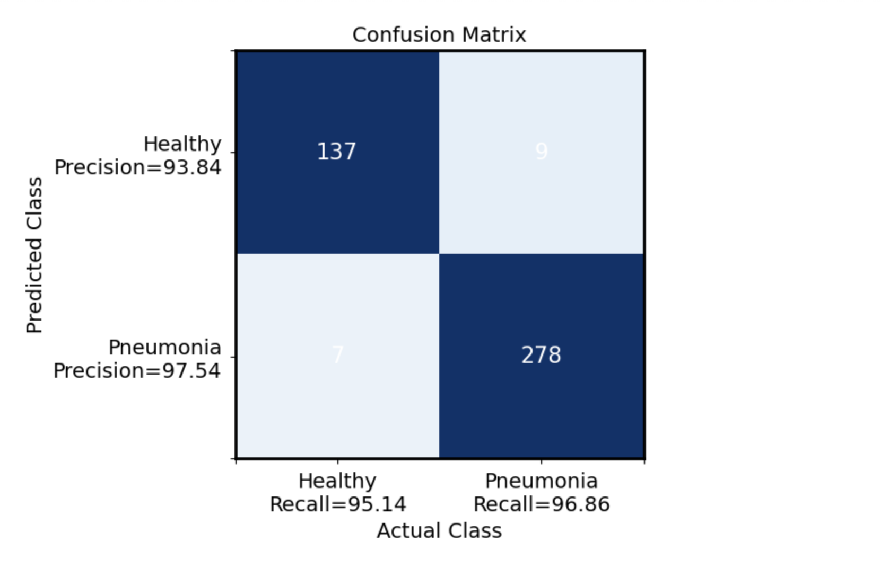

**Table 1.** The detailed calculation for cost-benefit analysis based on the confusion matrix.

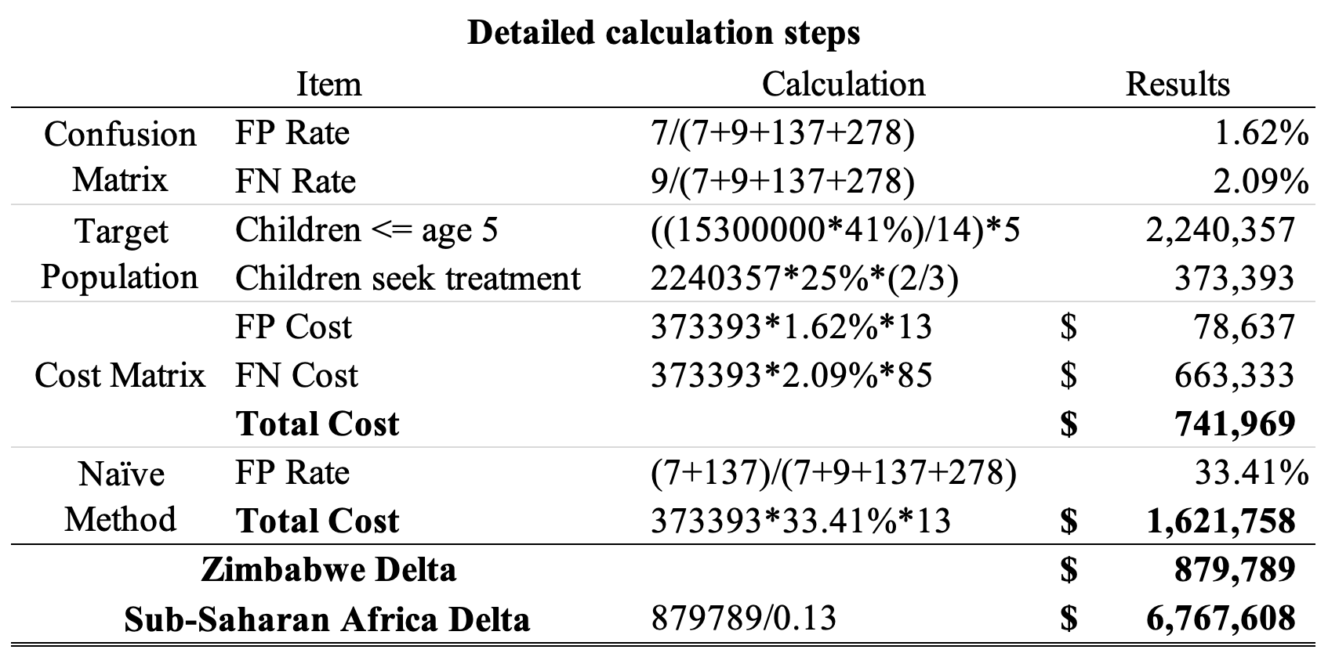

Reference

Childhood pneumonia: Everything you need to know. (n.d.). *UNICEF*. Retrieved from https://www.unicef.org/stories/childhood-pneumonia-explained#:~:text=Every%20year%2C%20it%20claims%20the,of%20these%20deaths%20are%20preventable.

Fighting for breath in Zimbabwe: A call to action on childhood pneumonia. (n.d.). *Save the children*. Retrieved from http://stoppneumonia.org/wp-content/uploads/2017/10/Zimbabwe-WEB.pdf.

Grimes, C. E., Law, R., Dare, A., Day, N., Reshamwalla, S., Murowa, M., George, P. M., Kamara, T. B., Mkandawire, N. C., Leather, A. J. M., & Lavy, C. B. D. (2017). Cost-effectiveness of two government district hospitals in Sub-Saharan Africa. *World Journal of Surgery, 41*(9), pp. 2187-2192. doi: 10.1007/s00268-017-4007-6.

Kebede, S., Mason, E., & Qazi, S. (2003). Report of a consultative meeting of children with pneumonia and HIV infection. *World Health Organization*. Retrieved from https://apps.who.int/iris/bitstream/handle/10665/42877/9241591285.pdf.

Okafor, U. V. (2009). Challenges in critical care services in Sub-Saharan Africa: Perspectives from Nigeria. *Indian Journal of Critical Care Medicine, 13*(1), pp. 25-7. doi: 10.4103/0972-5229.53112.

Pneumonia in children. (2022). *World Health Organization.* Retrieved from https://www.who.int/news-room/fact-sheets/detail/pneumonia.

POP1 Child population: Number of children (in millions) ages 0–17 in the United States by age, 1950–2021 and projected 2022–2050. (n.d.). *Child Stats.* Retrieved from https://www.childstats.gov/americaschildren/tables/pop1.asp.

World population dashboard, Zimbabwe. (n.d.). *United Nations Population Fund*. Retrieved from https://www.unfpa.org/data/world-population/ZW.